Do you need this template in black and white?
Follow these steps to print any template or document in grayscale for black and white printer or copier replications.

NOTE: If you have a black and white printer only, the file will automatically print in grayscale.

- Once you are done entering all your information and editing the template, choose File (or click the Office button in Office 2007), then Print from the menu bar.

- A print window will pop up. Click on the button titled Properties.
- A new pop-up window will appear with five tabs at the top. Click on the Color tab.

- In the Color tab, check the Print in Grayscale box located at the bottom of the pop-up window. Click OK, then click OK again.

- Your document will now print out in grayscale!

For technical assistance questions, feel free to email Sarah Sciandri at sarah.sciandri@cdph.ca.gov.
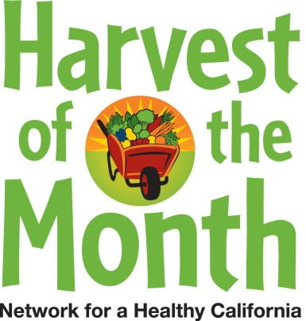
Integrate
Harvest of the Month in Your Worksite

Increase employee access to in-season and locally grown fruits and vegetables with these tips!

- Download the Harvest of the Month worksite toolkit each month from UC San Diego’s Harvest of the Month website (bit.ly/HOTMSDWorksite), and post the provided materials on your wellness board or around your worksite
- Order CSA (Community Supported Agriculture) Boxes for your office which contain locally grown and in-season produce
- Host a Harvest of the Month Recipe Contest. Employees have a potluck and submit their favorite healthy recipe featuring one of the Harvest of the Month selections
- Post UC San Diego’s Harvest of the Month Produce Calendar in your worksite and distribute copies to employees
- Increase Harvest of the Month signage near your employee cafeteria or vending machines
- Promote farmers’ markets located near your worksite to encourage employees to buy local Harvest of the Month produce

For CalFresh information, call 1-877-847-3663. Funded by USDA SNAP, an equal opportunity provider and employer. Visit www.cachampionsforchange.net for healthy tips. •California Department of Public Health

