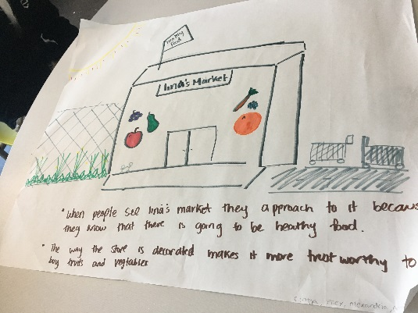
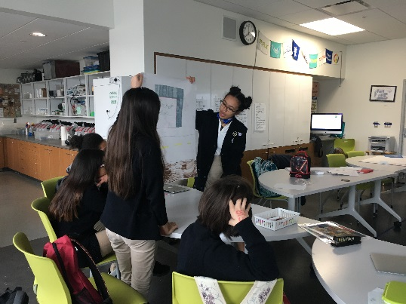
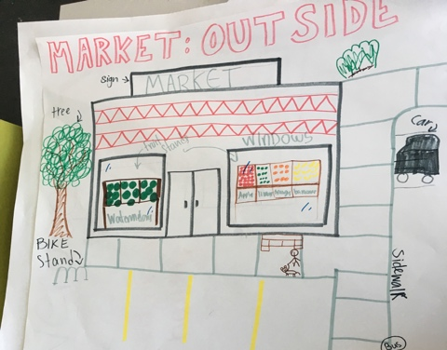
E3 Civic High Students Make Recommendations for
Healthy Community Markets

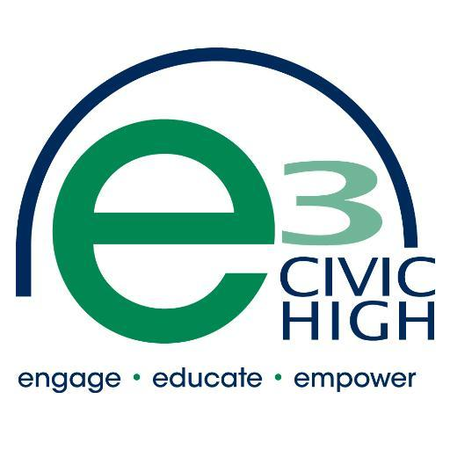
High School students at E3 Civic High in Downtown San Diego worked on a project with the Live Well Community Market team from UC San Diego’s Center for Community Health. Students were led through a workshop to help them understand food access problems in their neighborhoods and then they worked in teams to design their ideal healthy community market.

The following are changes the students wanted to share with you, market owners/managers, in order to help you work on improvements that are important to young shoppers that want to spend money at your market. Students made recommendations in the following categories: exterior improvement, promotion and display of healthy fresh foods and drinks, and easy and active ways to get to and from the market.

- Exterior Improvement:
- Must be clean on the outside!
- Recognizable branding
- Plants and trees make it look nicer and safer
- Display produce on the outside and make produce more easily seen from the outside or near the entrance
- Make nice, colorful, and clean advertisements for fresh produce and other healthy foods
- Buildings surrounding the market also must look nice and be clean in order to feel safe to shop (is there a business improvement group in your area that can help with this?)

- Promotion and Display of Healthy Fresh Foods & Drinks:
  - Easy to find and see in the market, example: Where are your bananas located? Can students find them quickly afterschool to buy one as a snack?
  - Put healthy foods and healthy drinks (like water) in the front of the market and near the cash register
  - Displays must be clean and well organized!
  - Variety of healthy snack options and other healthy drink options beyond water
  - Nice looking packaging
  - Advertise local products

- Easy and Active Ways to Get To and From the Market:
  - Good sidewalks (ask the City for improvements if it is public right of way)
  - Bus stop (if there is one by your market, is it clean and safe? If no, ask the City.)
  - Parking lot (if you have one, is it clean and are the spaces well-marked?)
  - Bike rack (you can ask for this as a business owner)
  - Good lighting outside (outside your market and street lighting for safety)
  - Trees and plants
  - Crosswalks
  - Stop lights and stop signs
  - Bike lanes

Students at E3 Civic High are also interested in urban gardening and like food markets that get their fruits and vegetables from community gardens. They think access to good food is important for everyone.

Young people in our neighborhoods have important opinions. Let your Live Well Community Market Program team representative know if you would like help working on some of the recommendations students suggested to you.

Live Well Community Market Team

Kate Mahoney, Community Health Specialist
C2mahoney@ucsd.edu
619-681-0675
M, Tue, Wed

Elle Mari, Director
emari@ucsd.edu
619-681-0655
Mon-Fri

Leah Contardi, Student Intern
lcontardi@ucsd.edu
619-681-0524
Tues

Katia Lopes-Gilbert, Student Intern
klopesgi@ucsd.edu
619-681-0524
Mon, Wed, Fri

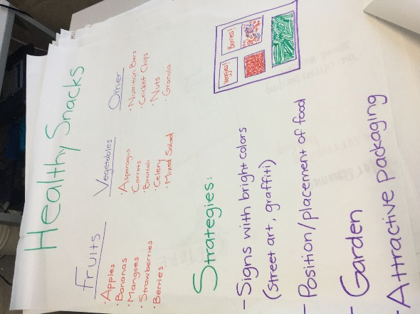
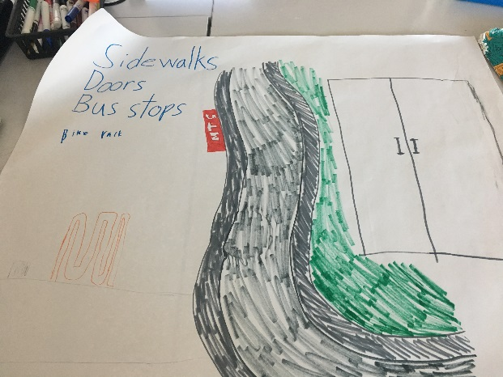
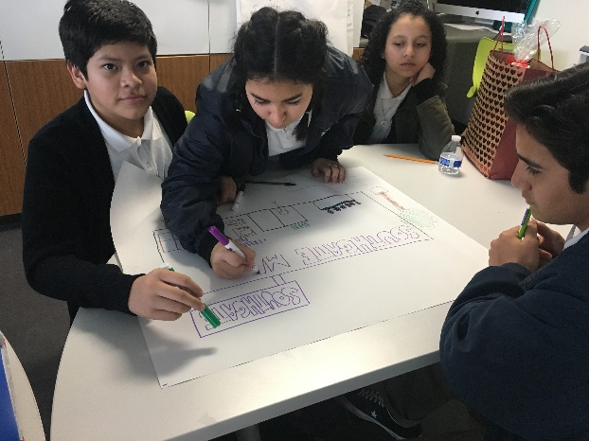

The Live Well Community Market Program is a project of the County of San Diego, implemented by UC San Diego, Center for Community Health. This work supports the County’s Live Well San Diego vision for a healthy, safe and thriving region.

