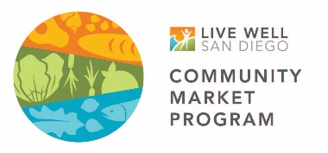
CROSSWALK AT THE INTERSECTION OF MARKET & DENBY
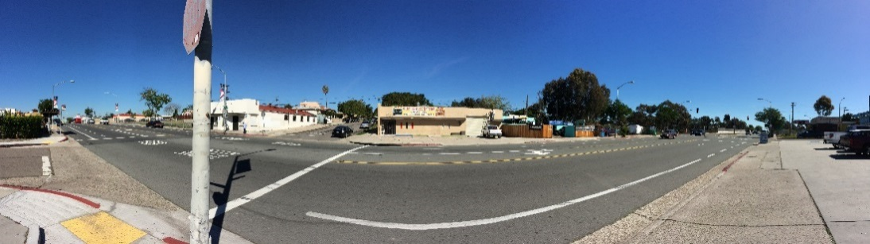

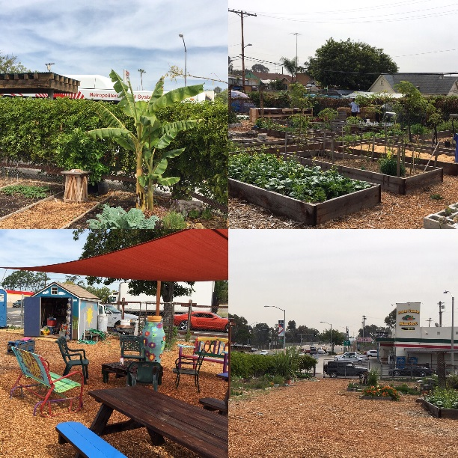
Important resources for food and community are located at the intersection of Market & Denby in the Mt. Hope neighborhood of Southeastern San Diego. Fresh Garden Market, a small neighborhood grocer, is located at this intersection and is currently making improvements to be a healthy and vibrant place for local residents to shop. The Mt. Hope Community Garden, operated by Project New Village, is also located here and provides a space for gardening, education, and community gathering. Residents, however, could not safely access these two resources. We advocated to the City of San Diego to fund and build a painted crosswalk with a beacon lights at the intersection of Market & Denby to improve pedestrian safety to and from this emerging Good Food District in Southeastern San Diego.

STEPS IN THE PROCESS: WHY DID WE NEED THIS CROSSWALK?

- Fresh Garden Market: This market was recruited into the Live Well Community Market Program (LWCMP) in March of 2016 and began working on improvement goals with LWCMP Staff. Owner Janice Hernandez expressed concern that the intersection out front was very dangerous and wanted to see a crosswalk built to provide safe and convenient walkability for her shoppers.

- Community Stakeholders: LWCMP Staff worked with the Diamond Business Association and Project New Village to determine if this issue resonated with the wider community. The LVCMP Team surveyed shoppers to ask about perceived safety and asked for suggestions for how to improve the intersection. A video of the testimonials is available here: http://ucsdcommunityhealth.org/news/walking-safely-to-the-good-food-district/

- Analyzed Data & Shared Out: LWCMP Staff analyzed survey data and shared it with partners. Highlights below:
- 72% of community members surveyed felt that the speed of cars on Market St. make it difficult or unsafe to walk to and from the locations they visit.
- The majority of community members surveyed reported to have seen or been in an accident or close call on Market St.
- The most common answer to the question “What would make you feel safer while crossing Market St.?” was a crosswalk with lighting. Stop signs and crosswalk murals were also popular responses.

- Traffic Evaluation: The City evaluated traffic in May of 2016 and engineers determined the intersection is unsafe, and qualified for a crosswalk with beacon lighting. There is currently an infrastructure deficient so no funding was available to make the improvement in 2016. The City released a performance audit in September 2016 on its programs responsible for improving pedestrian safety and found that resources had not been invested in the highest risk areas, among other findings. A brief of the report is available here: https://www.sandiego.gov/sites/default/files/17-006_highlights.pdf

- Media: KPBS released a story in September 2016 to further investigate the need for the crosswalk at Market & Denby and draw attention to the issue. The story is available here: http://www.kpbs.org/news/2016/sep/22/southeastern-san-diego-food-desert-cars-crosswalk/

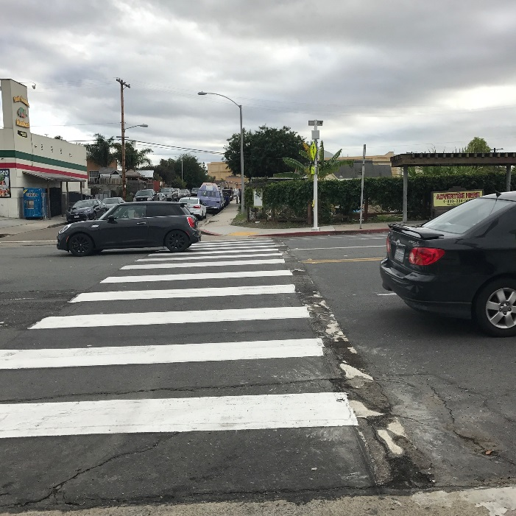
- Advocacy: LWCMP Team and partners continued to ask stakeholders such as local business, neighborhood councils, community planning groups, and others to ask District 9 to help prioritize implementation of this crosswalk in order to improve pedestrian safety in the emerging Good Food District envisaged and championed by Project New Village. All of the hard work paid off and the crosswalk was built in February of 2017.

- Looking Forward: LWCMP Team would like to thank all of our collaborating partners who helped move this project forward. However, the work here is not finished. LWCMP Team will continue gathering feedback from residents in Mt. Hope to ensure this crosswalk meets their needs on pedestrian safety. Together with the community, LWCMP Team will also continue identifying additional opportunities to improve access to healthy affordable foods for the residents of Southeastern San Diego.

PARTNERS INVOLVED IN THIS PROJECT INCLUDED:

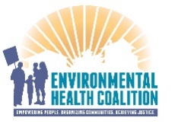
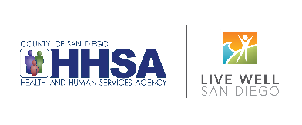
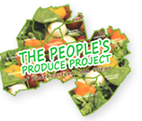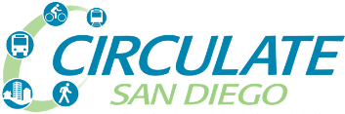

FOR MORE INFORMATION, PLEASE CONTACT:

Elle Mari, M.Sc., Director
Urban Food Environments
Center for Community Health
University of California, San Diego
E: emari@ucsd.edu
T: 619.681.0655
www.ucsdcommunityhealth.org

The Live Well Community Market Program is funded by the County of San Diego Health and Human Services Agency and implemented by UC San Diego, Center for Community Health. This work supports the County’s Live Well San Diego vision for a healthy, safe and thriving region.

