(YEAR) Action Plan
communication schedule | workplace overview (INSERT COMPANY NAME)
address (INSERT ADDRESS) | wellness lead (INSERT NAME)
start date (INSERT DATE) | phone (INSERT PHONE NUMBER) | employees (INSERT # OF EMPOYEES | sites (INSERT # OF SITES)

creating a culture of health
Program Promotion & Employee Education
Develop a comprehensive wellness initiative that promotes employee education and engagement

steps | timeframe | lead | resources
- Develop your organization’s unique wellness brand by selecting a program name, creating a mission and vision statement, and setting wellness goals. | T1. 3-6 mo. | L1. Wellness Comm. | - Starting a Wellness Committee (California Fit Business Kit)  - Wellness Program  Announcement email  - Wellness Board Materials (UCSD)  - Sign up for the Live Well @ Work newsletter  - MyPlate Resources
- Promote wellness activities and initiatives to employees through communication channels and maintaining a wellness board in employee break rooms. | T2. 1-2 mo. | L2. Wellness Comm.
- Schedule a series of 4 lunch & learn opportunities on stress management in partnership with Live Well @ Work community partners. | T3. 1-2 mo. | L3. Project Lead
- Evaluate your program through employee surveys and participation rates. | T4. Annually | L4. Wellness Comm.

creating healthy food environments
Healthy Meetings
Establish guidelines for meetings and events that encourage the consumption of healthy food and beverages

steps | timeframe | lead | resources
- Set healthy guidelines for your business. Think of creative ways to integrate the guidelines into employer-sponsored meetings and events. | T1. 3-6 mo. | L1. Wellness Comm. | - Healthy Meetings (California Fit Business Kit)  - Healthy Meeting Toolkit (NANA)  - Under Pressure (CDC)  - Tips for Offering Healthier Options and Physical Activity at Workplace Meetings and Events (CDC)  - Meet Well Pledge (HHSA)
- Offer healthy snack alternatives at meetings and events such as water or fruits and vegetables. | T2. 2-4 mo. | L2. Wellness Comm.
- Create a list of preferred healthy food vendors that your business uses for catered meetings. | T3. 2-4 mo. | L3. Wellness Comm.
- Establish a healthy meeting policy with your human resources department that outlines opportunities providing healthy food options for employees. | T4. 6-9 mo. | L4. Wellness Comm. & HR

creating healthy food environments
Healthy Vending
Develop healthy vending guidelines that promote serving healthy snacks and beverages

steps | timeframe | lead | resources
- Connect with your fiscal department to find out about your current vending contracts and what changes can be made. | T1. 1-2 mo. | L1. Project Leads | - Healthy Vending Criteria (California Fit Business Kit)  - Eat Well Standards: Beverage & Food Vending Guidelines  - Sample Healthy Vending Policies  - San Diego’s Healthy Vendor List  - Sample Employee Surveys
- Create a healthy vending plan that outlines timeline, goals, and promotion. | T2. 3-6 mo. | L2. Wellness Comm.
- Conduct employee surveys and taste tests to identify which products they would like offered in the vending machines. | T3. 2-4 mo. | L3. Project Leads
- Post promotional messaging on and around vending machines that encourage healthy options and nutrition information. | T4. 1-2 mo. | L4. Wellness Comm.
- Make the healthy options more appealing by decreasing their price and placing the healthier options at eye level. | T5. 3-6 mo. | L4. Project Leads

creating opportunities for physical activity
Physical Activity Clubs
Create clubs and promote fitness events that allow employees to be active before, during, and after work

steps | timeframe | lead | resources
- Identify what types of clubs and activities are of interest to staff. | T1. 1-2 mo. | L1. Wellness Comm. | - Physical Activity Clubs (California Fit Business Kit)  - Fitness Activity Survey  - Team In Training’s Corporate Wellness @ Work 5K Program  - Employee Fitness Surveys
- Create a simple activity-tracking log and promote the program to all employees through e-blasts and announcements. | T2. 1-2 mo. | L2. Wellness Comm.
- Host a kick-off event to launch the physical activity program/challenge with Live Well @ Work partner (e.g. Team in Training). | T3. 2-4 mo. | L3. Project Leads
- Provide incentives to participating employees (i.e. pedometers, water bottles, etc.) | T4. 1-2 mo. | L4. Project Leads

Employer Background: (INSERT SUMMARY OF ORGANIZATIONS KEY VALUES AND STRENGTHS)

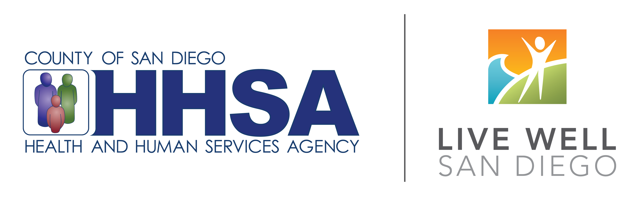
Made possible by funding from the Centers for Disease Control and Prevention, through the County of San Diego Health and Human Services Agency.

